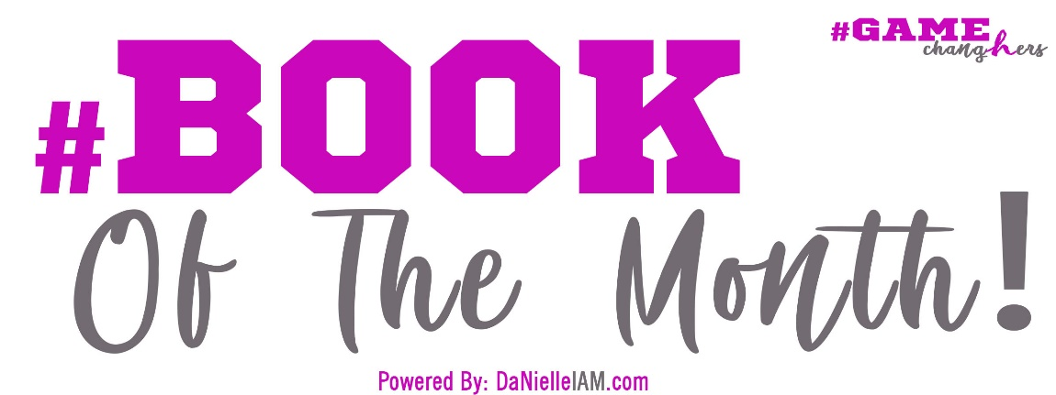
Discussion Questions:
1. HOW DID THE BOOK MAKE YOU FEEL?
- Were you amused, upset, bored, angry, intrigued?
- Did you have to force yourself to get through it or were you unable to put it down?
- Are you glad you read it?
2. HOW DO YOU FEEL ABOUT HOW THE STORY WAS TOLD OR HOW THE BOOK WAS WROTE?
- Did it start too slow or end unresolved?
- Do you wish it had been told/written from a different perspective?
- Did it jump around too much or hold you in suspense?
3. WHAT DID YOU THINK ABOUT THE MAIN CHARACTERS OR THE MAIN SUBJECT/TOPIC?
- Did you like them or it? Were they believable?
- Did you approve of their decisions and behavior?
- Who/What did you relate to the most/least?
4. WHICH PARTS OF THE BOOK STOOD OUT TO YOU?
- Are there any quotes, passages, scenes or chapters you found particularly compelling?
- Were there parts of the book you thought were incredibly unique, out of place, thought-provoking, or disturbing?
5. WHAT THEMES OR SETTINGS DID YOU DETECT IN THE STORY/BOOK?
- What were the main points you think the author was trying to make?
- Did you notice any symbolism?
6. WHAT DID YOU THINK ABOUT THE ENDING?
- Were you satisfied or disappointed with how the story/book ended?
- Is anything left unresolved or ambiguous?
- How do you picture the characters’ lives after the end of the story?
7. WHAT IS YOUR IMPRESSION OF THE AUTHOR?
- Does the story seem to fit with what you know of the author?
- What do you think about the author’s writing style?
- What do you think about the author’s storytelling ability?
- Would you read another book by the same author?
8. WHAT CHANGES/DECISIONS WOULD YOU HOPE FOR IF THE BOOK WERE TURNED INTO A MOVIE?
- Which sections would you cut?
- Who would you cast to play the main characters?
- If the book is already a movie, are you happy with the representation? Do you prefer the book or the movie?
9. HOW DOES THIS BOOK COMPARE TO OTHER BOOKS YOU’VE READ?
- Did you like it more or less than other books in the same genre?
- Is the book different in any way from the books you usually read?
10. HOW DID THIS BOOK CHANGE YOU?
- Do you have a new perspective as a result of reading this book?
- Did you learn something you didn’t know before?
- Has your attitude or behavior changed?

To JOIN “The ChangHER Reading” Book Club and JUMP IN on the FUN, VISIT US at: https://www.thegamechanghers.com/changherreadingbookclub

BOOK CLUB

