Defining the BRAND in YOU!
Step One: How Am I Unique?
A personal brand highlights the specific qualities you possess that allows you to stand out from the competition or from the norm. So to begin, therefore, you must start by defining what is unique or unusual about you by answering these 3 questions:
- What is your essence?
- What are you like to work with?
- What do people remember most about you and how would they describe the experience of working with you?
Step Two: How is What I Do Distinctive?
The next step is to look at how yourself as a whole and figure out how which you do is unique. Look at your interests, hobbies and preferences. For example, what do your three favorite books, movies or songs say about you? What would someone learn by knowing your taste in music, food or sports?
- What are your favorite interests? What do they say about you?
- How does what you do, combined with what makes you unique, distinguish you from your peers in your profession or field of expertise?
Step Three: Who is my Target Audience and Why I am the Best Person to Satisfy Their Needs?
Because creative artists do not work in a vacuum, the third step in creating a personal brand is identifying your target audience. This step is critical for two reasons: first, it validates that your unique gifts are commercially viable, and second, it helps clarify your objectives so you can map your career path as efficiently as possible. To complete step 3, answer these questions:
- Who is your ideal target audience? Create a profile of one individual who exemplifies the qualities of the audience you would most want to perform, teach or work for in your creative profession. Write down a list of these qualities.
- Rank these qualities in their order of importance to you.
- Why are you are uniquely positioned to satisfy the needs of this audience?
Step Four: Why Do I Do What I Do?
The last – and probably most important -- step in creating your personal brand is to commit to your brand on an emotional level in order to connect deeply with your target audience.
Ask Yourself the Following Questions:
If the world were a perfect place, what work would I be doing?
In this perfect world, what am I achieving through my work? In this perfect world, how am I impacting audiences?
These answers are your life purpose!
Create Your Brand Statement (i.e Your 30 Sec. ‘Elevator Pitch’)
Put these elements together into the following template to create your brand statement:
I am a_______________________________
(musician/artist/lawyer etc – how you see yourself professionally)

who___________________________________________________
(describe how you use your unique talents)
for ____________________________________________________
(describe your target audience) so they can ____________________________.
(describe the desired experience you want your audience to have)
Here is an Example of a Brand Statement or 30 Sec. ‘Elevator Pitch’:
I am a passionate, creative and inspirational musician who brings excitement, focus and leadership to open-minded, engaged and curious audiences (or students) in order to create a memorable experience they will want to share with their communities.
Congratulations! You now have a statement that crystallizes the essence of who you are and makes it clear to your target audience why they need you.
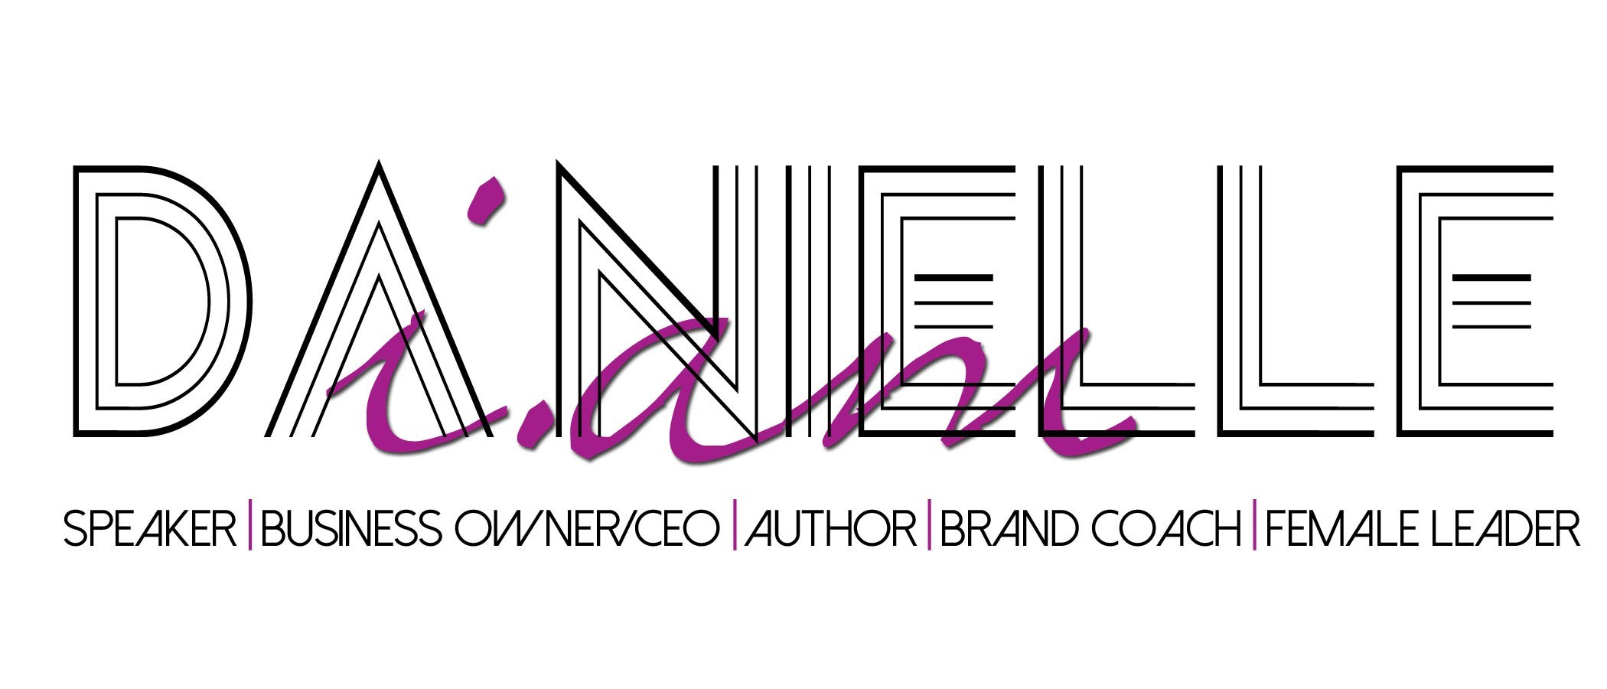
For any business and/or branding products and services visit my company website at www.GoUB4ME.com. To schedule me for a coaching session, branding workshop, speaking engagement, and/or to host an event, visit my personal website at www.DaNielleIAM.com and if you are a Woman of God in Business in need of a Community of Support, then feel free to visit “The Game ChangHers” Women’s Organization at TheGameChangHers.com

